The Effects of Gender on Traffic Violations

By Mark Middleton

11/27/2023

**Abstract**

The focus of this study was to demonstrate the differences in gender regarding traffic violations. Specifically, two questions were asked: is there a correlation between traffic violations and gender and which violations are gender specific? In order to study these questions, data was obtained from the Rhode Island Police. This information covers traffic violations over the span of ten years, between 2005 and 2015. Data was then organized and refined to gain a clear picture of the situation. After splitting the data into the gender categories of male and female, the data was then broken down to the reasons for each traffic stop. Doing so would demonstrate the amount of traffic violations committed between the genders and then also show what gender committed, which violation and to which degree. After breaking down the gender categories, data indicated strongly that males commit more traffic violations than females. In fact, male traffic violation incidents were over double that of the female violations. So, it became clear that males commit traffic violations more than females. However, this did not complete the focus of the study. Further analysis of the data shows that there is indeed a difference in which violations are committed more by each gender.

**Introduction**

It is arguable that the legality of traffic stops and searches is muddy and could be construed by many as discrimination, but is it justifiable? After all, insurance companies often require their insured male drivers under the age of between 16 and 20 to pay a premium, which increases their payments in comparison to female counterparts by 9% to 11% (Bishop). Rates of traffic violations and accidents are what these companies based their price increases on. Insurance payouts for men occur far more often, which makes the cost of insuring them higher than females. An argument could be made that there is a distinction between a private company adjusting its rates and the government weaponizing statistics in a prejudicial fashion. A fair question, but if the data is more heavily focused in one direction, it is then incumbent upon law enforcement to utilize that information to properly protect and serve the citizenry. If genders do commit violations, which violations are specific to each gender? But first, the question must be asked: is there a significant correlation between traffic violations and gender? These two questions are at the core of this issue. While it is morally dubious, it is important to understand the facts and study the data in order to answer these questions to provide a clear picture of the relationship between gender and traffic violations.

**Data Characteristics**

The data used in this paper is from Rhode Island Police. It contains 91,742 traffic violations from January of 2005 to December of 2015.

The data provides the following information:

* Date of offense
* Time of the offense
* County which the offense took place
* The offenders gender
* The offenders race
* Violation data
* Whether a vehicle search was conducted
  + What type of search was conducted, if necessary
* The outcome of the stop
* Whether the offender was arrested
* The duration of the traffic stop
* Whether the stop was drug related
* The district that the stop took place

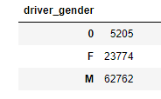

When dividing the data by gender, we see that men make up for 62,762 of the 91,742 traffic violations in this record (Figure 1). This is opposed to the 23,774 females who were recorded in traffic offenses. Therefore, men accounted for 68.4% of traffic violations over ten years, compared to only 25.9% violations committed by females.

Figure 1: Offending Genders

It is clear to see that even adding the “Other” categories where the gender of the traffic offender to the female category would still result in males dominating the sheer number of violations (Figure 2).

Figure 2: Gender Histogram

Figure 2: Distribution of Gender

The violations were then divided into categories of violation type to show which gender committed which violation (Figure 3).

The violations committed by traffic offenders were:

* Equipment
* Moving Violation
* Registration/Plates
* Seat Belt
* Speeding
* Other
* Unknown/Unspecified

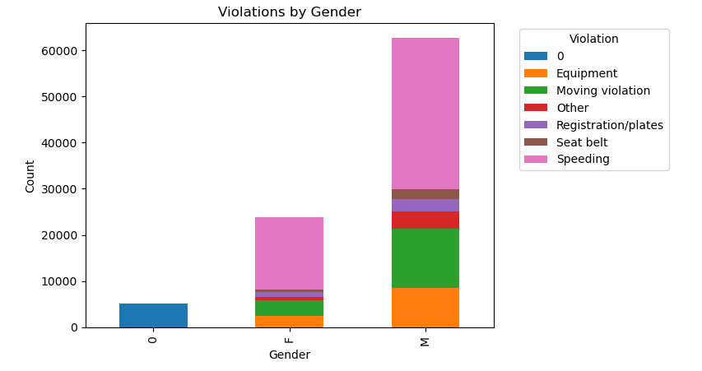

Figure 3: Violation Histogram

Males committed violations in higher numbers than their female counterparts, but the data was organized to show the total violations committed by each gender to demonstrate the rates at which each gender committed each violation.

Figure 4: Male Violations Histogram

Overall, males committed 32,777 speeding violations, 12,938 moving violations, 8,240 equipment violations, 2,647 registration/plate violations, 2,278 seat belt violations, and 3,702 miscellaneous violations (Figure 4). Thus, speeding made up 52.2%, moving violations were 20.6%, 13.1% were equipment violations, 4.12% registration/plate violations, only 3.63% seat belts and 7.35% miscellaneous violations.

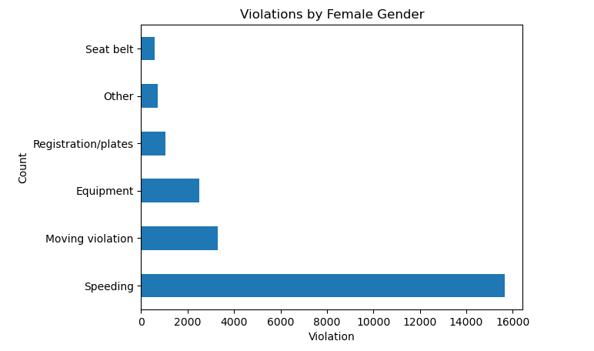

Figure 5: Female Violations Histogram

Overall, females committed 15,646 speeding violations, 3,286 moving violations, 2,501 equipment violations, 1,056 registration/plate violations, 578 seat belt violations, and 707 miscellaneous violations (Figure 5). For females, the make up the violations were: 65.8% speeding, 13.8% moving violations, 10.5% equipment related, 4.44% registration/plate violations, 2.43% seat belt violations, and 2.97% miscellaneous violations.

**Model Selection and Interpretation**

The models chosen were selected to visually demonstrate the offenses committed by each party. It was then divided by gender and then again by violation. By doing so, the data may be read in such a way that the data can be easily interpreted. Histograms were the best method to do this, as they quickly show the counts of each violation, whether by comparing them each by gender or alone.

Still, by glance alone, it would seem as though men are more likely to offend than women. This is true, based solely on the numbers of violations, but a more nuanced picture is formed when further analyzing the data. Speeding, for example, constituted 52.2% of male offenses, while it made up 65.8% of female offenses. This means that, while men are more likely to commit the offense overall, a woman, when she does commit a violation, is more likely to speed than a man. That said, the rest of the violations were actually very close, in gender comparison. Men were higher in moving violations but were only roughly 7% more likely to do so than their female counterparts. The rest were only a few percentage points away from one another, with the exception of miscellaneous or “other” violations.

**Conclusion**

After analyzing the data provided by the Rhode Island Police, it was shown that males dominated the overall traffic offenses committed between 2005 and 2015. This ten-year period showed various violations committed between men and women, with men committing them at well over twice the rate of women. Thus, men were overall more likely than women to commit a traffic violation. However, after further breaking down the data provided, it became clear that women, strangely, are more likely than men to speed, flipping conventional knowledge. In fact, the overall rate of violations committed by gender were roughly equal. This information is very interesting, as only a surface level analysis shows men to be more likely to commit all violations than women. Is there a significant correlation between traffic violations and gender? Yes, males are over twice as likely to offend than females. Is there a significant correlation between traffic violations and gender? It seems that women might be more likely to speed than men, but overall, no.

**References**

Bishop, Lindsay. “How Much You'll Pay for Car Insurance for Your Age & Gender.” *ValuePenguin*, 7 August 2023, https://www.valuepenguin.com/how-age-affects-auto-insurance-costs. Accessed 30 November 2023

**Appendix**



Figure 1: Offending Genders

Figure 2: Distribution of Gender

Figure 2: Gender Histogram

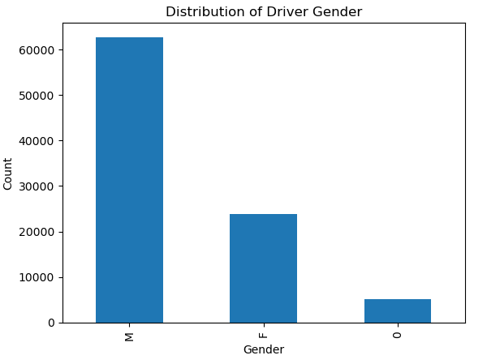



Figure 3: Violation Histogram

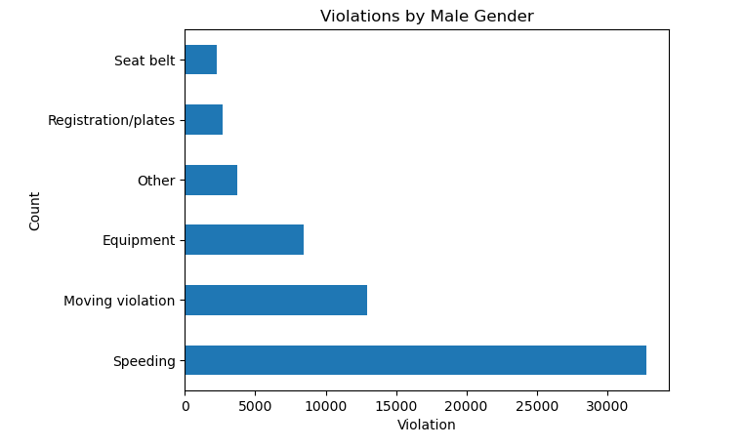

Figure 4: Male Violations Histogram



Figure 5: Female Violations Histogram

Figure 5: Female Violations Histogram